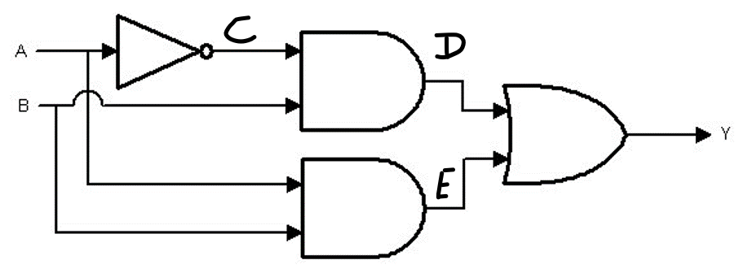

|  |  |  |  |  |  |
| --- | --- | --- | --- | --- | --- |
| A | B | C | D | E | Y |
| 0 | 0 | 1 | 0 | 0 | 0 |
| 0 | 1 | 1 | 1 | 0 | 1 |
| 1 | 0 | 0 | 0 | 0 | 0 |
| 1 | 1 | 0 | 0 | 1 | 1 |

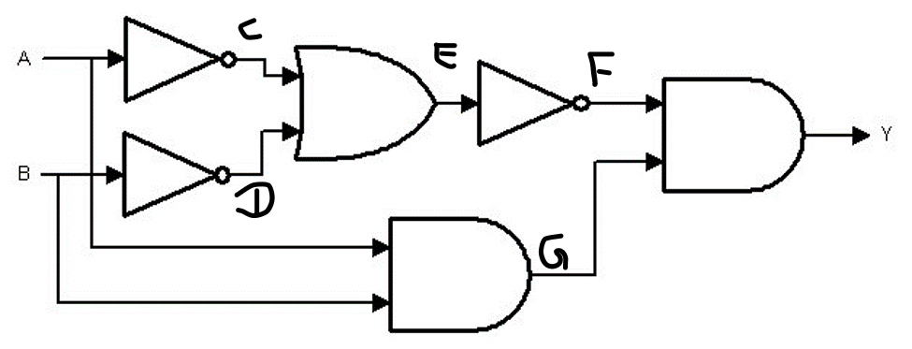

|  |  |  |  |  |  |  |  |
| --- | --- | --- | --- | --- | --- | --- | --- |
| A | B | C | D | E | F | G | Y |
| 0 | 0 | 1 | 1 | 1 | 0 | 0 | 0 |
| 0 | 1 | 1 | 0 | 1 | 0 | 0 | 0 |
| 1 | 0 | 0 | 1 | 1 | 0 | 0 | 0 |
| 1 | 1 | 0 | 0 | 0 | 1 | 1 | 1 |

Convert 110101 from Binary to Decimal

1+4+16+32 = 53

Convert 98 from Decimal to Binary

98 -64 = 34 – 32 = 2 – 2 = 0

1100010

Convert 534 from Decimal to Hexa

534/16 = 33.375

.375*16 = 6

33/16 = 2.0625

.0625/16 = 1

2/16 = .125

.125*16 = 2

216

Convert 1FA from Hexa to Decimal Conversion

10*1 = 10

15*16 = 240

1*256 = 256

10+240+256 = 506